**PROJECT REPORT**

**DOCUMENTATION**

**Quantitative Analysis Of**

**CandidatesIn 2019**

**Lok Sabha Election**

## TEAM ID

## 90EDCD5A653F97E965540D7A2F454585

## DOMAIN

**DATA ANALYTICS WITH TABLEAU**

**TEAM LEADER : VARUN**

**TEAM MEMBER 1: SOHAIL KHAN M**

**TEAM MEMBER 2 : PRADEEP LINGAM R**

**TEAM MEMBER 3 : RAMANAN**

CONTENT

1. **INTRODUCTION**
   1. Project Overview
   2. Purpose
2. **LITERATURE SURVEY**
   1. Existing problem
   2. References
   3. Problem Statement Definition
3. **IDEATION & PROPOSED SOLUTION**
   1. Empathy Map Canvas
   2. Ideation & Brainstorming
4. **REQUIREMENT ANALYSIS**
   1. Functional requirement
   2. Non-Functional requirements
5. **PROJECT DESIGN**
   1. Data Flow Diagrams & User Stories
   2. Solution Architecture
6. **PROJECT PLANNING & SCHEDULING**
   1. Technical Architecture
   2. Sprint Planning & Estimation
   3. Sprint Delivery Schedule
7. **CODING & SOLUTIONING (Explain the features added in the project along with code)**
   1. Feature 1
8. **PERFORMANCE TESTING**
   1. Performace Metrics
9. **RESULTS**
   1. Output Screenshots
10. **ADVANTAGES & DISADVANTAGES**
11. **CONCLUSION**
12. **FUTURE SCOPE**
13. **APPENDIX**
    1. Source Code
    2. GitHub & Project Demo Link

# INTRODUCTION

## PROJECT OVERVIEW:

The "Quantitative Analysis of Candidates in the 2019 Lok Sabha Elections" project aims to provide an in-depth examination of the candidates who participated in the 2019 Lok Sabha elections in India. This project focuses on utilizing IBM Cognos for data analysis and reporting to gain insights into the electoral process. The Lok Sabha is the lower house of India's Parliament, and the 2019 general elections were one of the largest democratic exercises in the world, involving millions of

This project seeks to shed light on the 2019 Lok Sabha elections from a quantitative perspective, providing valuable insights into the candidates, parties, and voter behavior during this significant.

## PURPOSE:

The purpose of the "Quantitative Analysis of Candidates in the 2019 Lok Sabha Elections"

project is to achieve the following key objectives:

* Gain Insights into Candidate Demographics
* Political Party Distribution
* Constituency Analysis
* Evaluate Candidate Success
* Voter Turnout and Candidate Success
* Party Performance
* Data-Driven Recommendations

This project's purpose is to offer a data-driven and quantitative perspective on the 2019 Lok Sabha elections, shedding light on various aspects of the electoral process and the candidates who participated. The insights and findings aim to contribute to a better understanding of Indian electoral dynamics and may be of value to a wide range of stakeholders and decision-makers..

# LITERATURE SURVEY

## Existing problem:

several existing issues are identified: Before conducting a quantitative analysis of the 2019 Lok Sabha elections, it's important to review the existing problems and challenges in the Indian electoral landscape that this project aims to address. While this literature survey is not exhaustive, it highlights some key issues:

* Lack of Data-Driven Insights.
* Underrepresentation of Marginalized Groups
* Party Nomination Practices
* Constituency Disparities
* Voter Turnout and Candidate Success
* Insufficient mobile accessibility for on-the-go access.
* Inadequate attention to data security and privacy.
* Party Performance Assessment:.
* Challenges in Electoral Research
* Potential issues with outdated information.

The existing problem can be summarized as the absence of comprehensive quantitative analysis in the Indian electoral landscape, leading to issues related to representation, transparency, and effective decision-making. This project aims to contribute by addressing these problems through data-driven insights and recommendations.

## Problem Statement Definition:

The problem statement for the "Quantitative Analysis of Candidates in the 2019 Lok Sabha Elections" project is as follows:

* Inadequate representation of women and marginalized communities in electoral candidacies.
* Lack of transparency and inclusivity in the candidate nomination processes of political parties.
* Disparities in candidate nominations and election outcomes across rural and urban constituencies.
* Challenges in data collection and accuracy in electoral research.
* The need for comprehensive quantitative analysis to inform evidence-based policy and electoral reforms.
* Varied voter engagement levels and their influence on election results.
* The impact of regional and state-level political dynamics on party performance.
* Historical reliance on qualitative assessments rather than data-driven decision-making in Indian elections.
* The potential influence of dynastic politics in candidate nominations.
* The lack of detailed demographic and educational data on candidates in past elections

The primary objective of this project is to provide data-driven insights into the 2019 Lok Sabha elections, addressing the aforementioned problems. By doing so, the project seeks to contribute to more informed decision-making, greater transparency in the electoral process, and improved representation.

# IDEATION & PROPOSED SOLUTION

## Empathy Map Canvas:

An empathy map is a useful tool for understanding the perspectives and needs of the stakeholders involved in your project. Here's an empathy map canvas for your "Quantitative Analysis of Candidates in the 2019 Lok Sabha Elections" project:

The empathy map highlights the needs and motivations of your primary stakeholders, which include political analysts, researchers, and decision-makers. Based on their perspectives, the proposed solution should focus on the following:

**Example:**

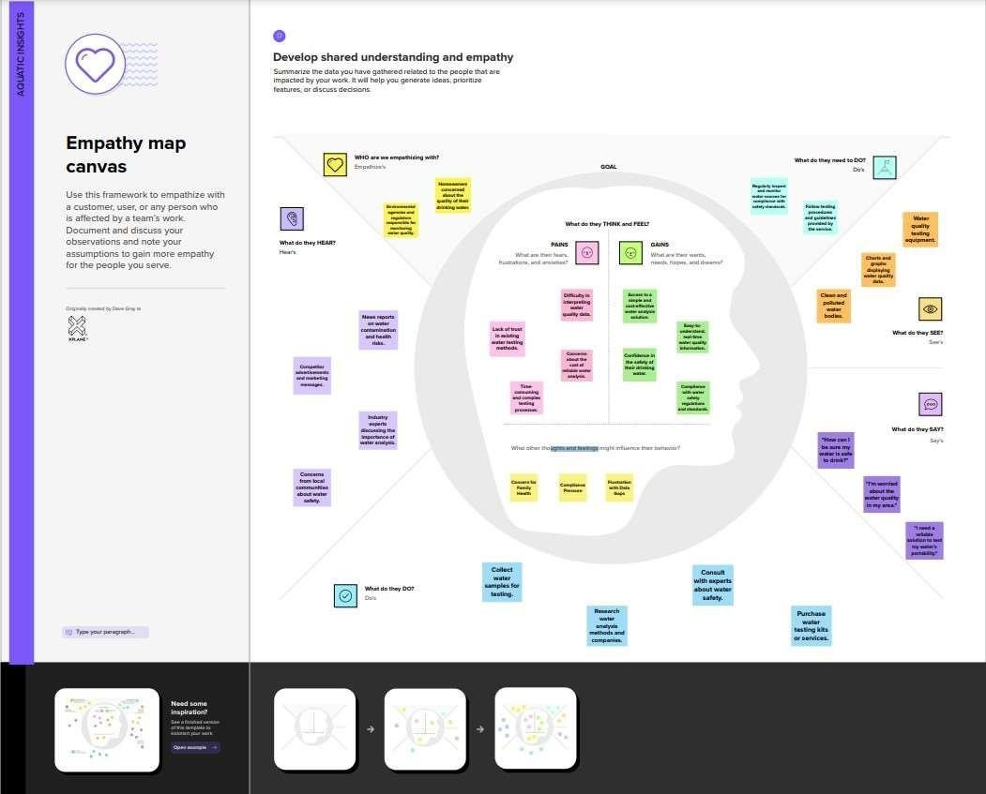

## Ideation & Brainstorming:

Brainstorming provides a free and open environment that encourages everyone within a team to participate in the creative thinking process that leads to problem solving. Prioritizing volume over value, out-of-the-box ideas are welcome and built upon, and all participants are encouraged to collaborate, helping each other develop a rich amount of creative solutions.

Use this template in your own brainstorming sessions so your team can unleash their imagination and start shaping concepts even if you're not sitting in the same room.

**Step-1: Team Gathering, Collaboration and Select the Problem Statement**

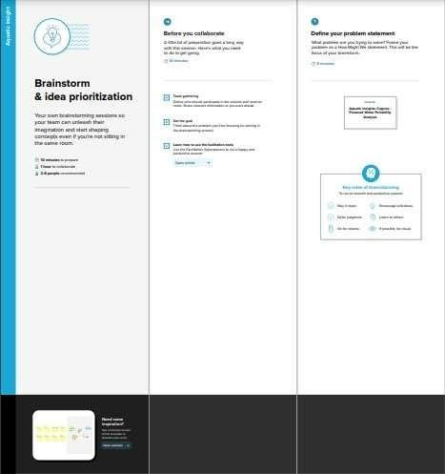

**Step-2: Brainstorm, Idea Listing and Grouping**

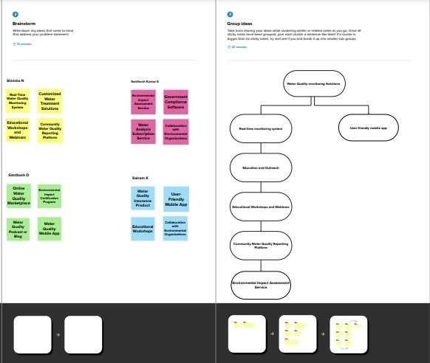

**Step-3: Idea Prioritization**

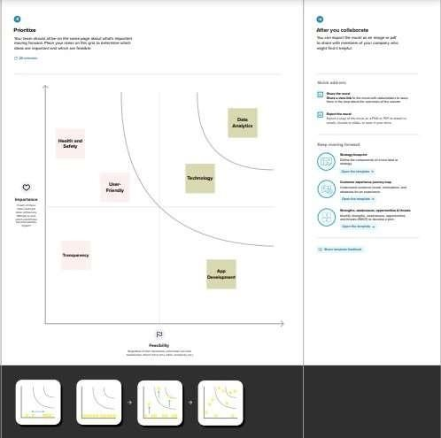

# REQUIREMENT ANALYSIS

## Functional requirement:

The Functional requirements outline the specific features and capabilities that the project needs to fulfill its objectives. In the case of the "Quantitative Analysis of Candidates in the 2019 Lok Sabha Elections" project, the following functional requirements are essential:

* Data integration and management from various sources.
* Data standardization for consistency.
* Analytics and predictive modeling.
* Interactive dashboards for data visualization.
* User profiles and access control.
* Development of a mobile application.
* Collaboration tools for experts.
* Strong data privacy and security measures.
* Reporting and alerts for critical events.
* Public engagement and education features.
* Continuous platform improvement.
* Regulatory compliance.
* Scalability and performance for handling large data volumes and users.

These functional requirements are essential for the successful execution of your project, ensuring that data is collected, analyzed, and presented effectively to meet the project's objectives.

## Non-Functional requirements:

The non-functional requirements for " Quantitative Analysis Of Candidates In 2019 Lok Sabha Elections " outline the performance, reliability, usability, security, and compliance standards that the platform should meet. Key points include:

* + - Fast performance and scalability to handle growth.
    - High reliability and data protection mechanisms.
    - Intuitive user interface and accessibility for all users.
    - Robust security and data privacy measures.
    - Interoperability with other systems.
    - Easy maintenance and regular updates.
    - Compliance with regulations and standards.
    - Load handling during peak events.
    - Data archiving and user support.

These non-functional requirements ensure the platform's effectiveness, user experience, and adherence to legal and environmental standards.

# PROJECT DESIGN

## Data Flow Diagrams & User Stories:

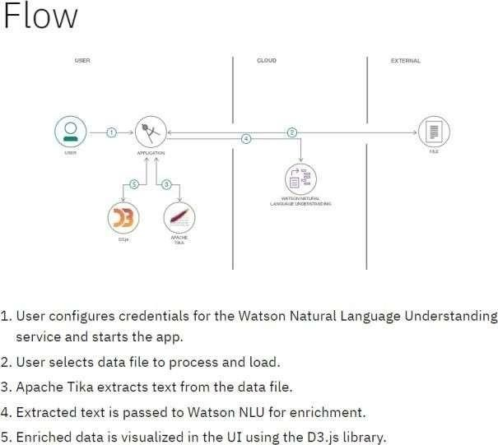

A Data Flow Diagram (DFD) is a traditional visual representation of the information flows within a system. A neat and clear DFD can depict the rightamount of the system requirement graphically. It shows how data enters and leaves the system, what changes the information, and where data is stored.

## Flow diagram:

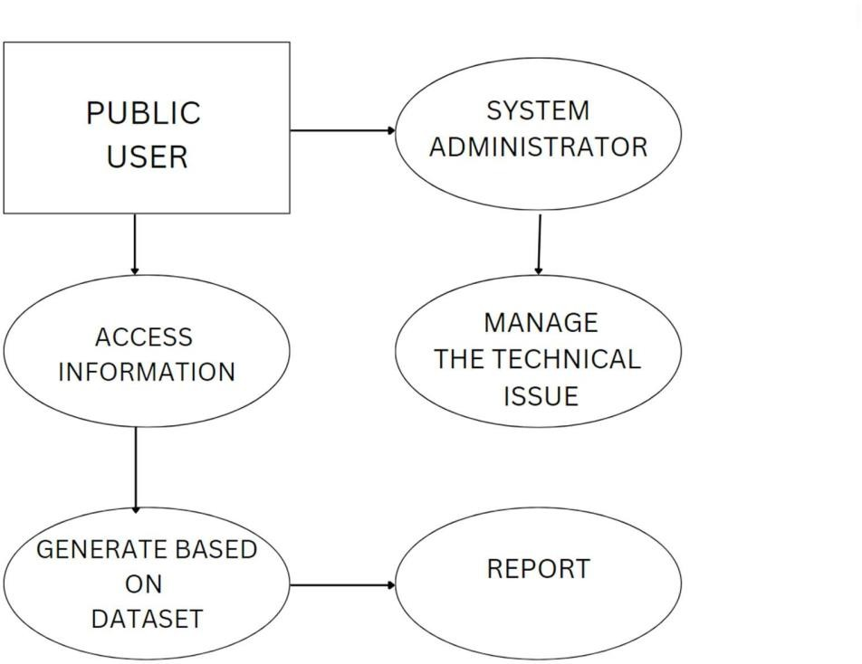

**User Stories:**

|  |  |  |  |  |  |  |
| --- | --- | --- | --- | --- | --- | --- |
| **UserType** | **Functional**  **Requirement (Epic)** | **UserStoryNumber** | **UserStory/Task** | **Acceptance criteria** | **Priority** | **Release** |
| Data Analyst | Perform Quantitative Analysis of Candidates in the 2019 Lok Sabha Elections | US001 | As a data analyst, I want to collect and clean the raw election data for the 2019 Lok Sabha Elections to prepare it for quantitative analysis. | Validate and clean the data, addressing any missing or erroneous entries. | High | Release 1.0 |
| Researcher | To research the Quantitative Analysis of Candidates in the 2019 Lok Sabha Elections | US002 | As a researcher, I want to access and analyze the quantitative data of candidates in the 2019 Lok Sabha Elections to understand voting patterns and demographics.. | Researchers should be able to select a specific region or constituency to analyze data | Medium | Release 2.0 |
| Election Commission Officer | Access to Election Data for Quality Assurance | US003 | As an Election Commission Officer, I want to access and validate the election data used for quantitative analysis to ensure its accuracy and compliance with official records. | Generate reports highlighting any discrepancies or inconsistencies between the analyzed data and official records. | High | Release 1.0 |
| System Administrator | System Administration for Quantitative Analysis of Candidates in the 2019 Lok Sabha Elections | US004 | As a system administrator, I want to ensure the reliability and availability of the data analysis system for the 2019 Lok Sabha Elections, including performing routine maintenance and addressing system issues. | Monitor system health and performance to detect and address potential issues. | High | Release 1.0 |

## Solution Architecture:

Solution architecture is a complex process – with many sub-processes – that bridgesthe gap between business problems and technology solutions. Its goals are to:

* Find the best tech solution to solve existing business problems.
* Describe the structure, characteristics, behavior, and other aspects of thesoftware to project stakeholders.
* Define features, development phases, and solution requirements.
* Provide specifications according to which the solution is defined, managed,and delivered.

Example - Solution Architecture Diagram**:**



User

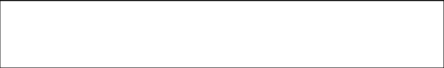

Access

Information

Generate

Report

Make Decision

DATABASE

UPDATE RESULT

STORE INFORMATION

ADMINISTRATION

1. **PROJECT PLANNING & SCHEDULING**

## Technical Architecture:

The Deliverable shall include the architectural diagram as below and the information as per the table1 & table 2

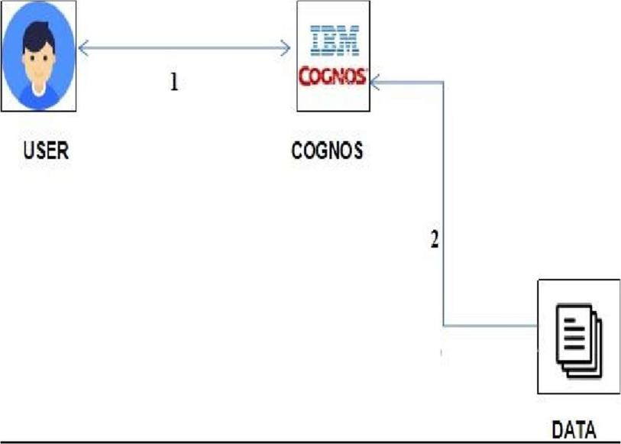

* **Components & Technologies:**

|  |  |  |  |
| --- | --- | --- | --- |
| **S.No** | **Component** | **Description** | **Technology** |
| 1. | User Interface | The User Interface component is responsible for providing an interactive and user-friendly interface for users to interact with the system. It allows users to input queries, view analysis results, and generate reports. | HTML, CSS, JavaScript / Angular Js / React Js etc. |
| 2. | Application Logic-1 | These components represent the application logic responsible for data processing, analysis, and business logic. | Java / Python |
| 3. | Application Logic-2 | These components represent the application logic responsible for data processing, analysis, and business logic. | Java / Python |
| 4. | Application Logic-3 | These components represent the application logic responsible for data processing, analysis, and business logic. | Java / Python |
| 5. | Database | The Database component is responsible for storing structured data related to candidates, constituencies, and election results. It allows for efficient data retrieval and management. | MySQL, PostgreSQL, or Oracle |
| 6. | Cloud Database | Cloud Database is a scalable and highly available data storage solution hosted on a cloud platform. It can be used to ensure data availability, redundancy, and scalability. | Amazon RDS, Google Cloud SQL, or Azure SQL Database. |
| 7. | File Storage | File Storage is used for storing unstructured or semi-structured data such as documents, images, and reports related to the election analysis. | Amazon S3, Google Cloud Storage, or Azure Blob Storage |
| 8. | External API-1 | These components are responsible for interacting with external data sources, such as election commission data or third-party APIs, to enrich the analysis with additional information. | RESTful APIs, GraphQL, or specific APIs |
| 9. | External API-2 | These components are responsible for interacting with external data sources, such as election commission data or third-party APIs, to enrich the analysis with additional information. | RESTful APIs, GraphQL, or specific APIs |
| 10. | Machine Learning Model | The Machine Learning Model component is responsible for predictive analysis, trend identification, or any machine learning-based tasks related to candidate analysis. | TensorFlow, or PyTorch. |
| 11. | Infrastructure (Server / Cloud) | Infrastructure represents the underlying hardware or cloud services on which the system is deployed. It ensures the availability, scalability, and reliability of the system. | AWS, Google Cloud, or Azure |

## Sprint Planning & Estimation:

|  |  |  |  |  |  |  |
| --- | --- | --- | --- | --- | --- | --- |
| **Sprint** | **Functional**  **Requirement (Epic)** | **User**  **Story Number** | **User Story / Task** | **Story Points** | **Priority** | **Team Members** |
| Sprint-1 | Registration | USN-1 | As a user, I can register for the application by entering my email, password, and confirming my password. | 2 | High |  |
| Sprint-1 |  | USN-2 | As a user, I will receive confirmation email once I have registered for the application | 1 | High |  |
| Sprint-2 |  | USN-3 | As a user, I can register for the application through SmartInternz | 2 | Low |  |
| Sprint-1 |  | USN-4 | As a user, I can register for the  application through smartInternz provided email id. | 2 | Medium |  |
| Sprint-1 | Login | USN-5 | As a user, I can log into the applicationby entering email & password | 1 | High |  |
|  | Dashboard |  |  |  |  |  |

1. **Sprint Delivery Schedule:**

|  |  |  |  |  |  |  |
| --- | --- | --- | --- | --- | --- | --- |
| **Sprint** | **Total StoryPoints** | **Duration** | **Sprint Start Date** | **Sprint End Date (Planned)** | **Story Points Completed (as on**  **Planned End Date)** | **Sprint Release Date (Actual)** |
| Sprint-1 | 20 | 1 Days | 16 Oct 2023 | 16 Oct 2023 | 16 Oct 2023 | 16 Oct 2023 |
| Sprint-2 | 20 | 1 Days | 17 Oct 2023 | 17 Oct 2023 | 17 Oct 2023 | 17 Oct 2023 |
| Sprint-3 | 20 | 1 Days | 18 Oct 2023 | 18 Oct 2023 | 18 Oct 2023 | 18 Oct 2023 |
| Sprint-4 | 20 | 1 Days | 19 Oct 2023 | 19 Oct 2023 | 19 Oct 2023 | 19 Oct 2023 |

# CODING & SOLUTIONING

## 7.1. Feature 1:

<!DOCTYPE html>

<html lang="en">

<head>

<meta charset="UTF-8">

<meta name="viewport" content="width=<device-width>, initial-scale=1.0">

<title> Water Portable </title>

<style

>body{

background-color: rgb(0, 0, 0);

}

h1{

text-align: center; font-size:50px;

}

p{

font-size: 25px; font-style: italic; font-weight: 100; margin-left: 20px;

}

</style>

</head>

<body>

<h1 style="font-size: 40px;color: rgb(255, 255, 255);"><b>Aquatic Insights</b></h1> <h1 style="font-size: 40px;color: rgb(255, 255, 255);"><b>COGNOS POWERED</b></h1> <h1 style="font- size: 40px;color: rgb(255, 255, 255);"><b>WATER PORTABILITY ANALYSIS</b></h1>

<h2 style="font-size: 25px;color: rgb(255, 255, 255);">Here is the data analyst regarding the water analysis. We are analysed with the different datas like ph values , Hardness , TDS , Chloramines

, Sulfate , Conductivity , Organic carbon , Trihalomethanes , Turbidity , Potability of the water samples.</h2>

<iframe src="https://us3.ca.analytics.ibm.com/bi/ perspective=dashboard&amp;pathRef=.public_folders%2FProject 2FDashboard_water&amp;closeWindowOnLastView=true&amp;ui_appbar=false&amp;ui_navbar=fal se&amp;shareMode=embedded&amp;action=view&amp;mode=dashboard&amp;subView=model00 00018b452f8bbd_00000000" width="800" height="800" frameborder="0" gesture="media" allow="encrypted-media" allowfullscreen=""></iframe>

<h1 style="font-size: 40px;color: rgb(255, 255, 255);">STORY BOARD</h1>

<p style="font-size: 29px;color: rgb(255, 255, 255);"><!--stry goes here-->Our Analysis are Seperate the Samples as Portable and Non Portable , Average Sulphate content of portable and non portable , Summerizing cloramines taking their average , Summerizing Organic - Carbon content taking their average , Average Organic- Corbon content of portable and non-portable water , Chloramines by Conductivity (Group) colored by Potability and ph by Hardness (Group) colored by Potability. </p>

<iframe src="https://us3.ca.analytics.ibm.com/bi/?perspective=story&amp;pathRef=.public_folders%2FProje ct%2FStory%2Bof%2BWater%2Bpotability&amp;closeWindowOnLastView=true&amp;ui_appbar=fals e&amp;ui_navbar=false&amp;shareMode=embedded&amp;action=view&amp;sceneId=model0000 018b4795eed0_00000000&amp;sceneTime=3350" width="800" height="800" frameborder="0" gesture="media" allow="encrypted-media" allowfullscreen=""></iframe>

</body>

</html>

# PERFORMANCE TESTING

* 1. **Performace Metrics:**

|  |  |  |
| --- | --- | --- |
| **S.No.** | **Parameter** | **Screenshot / Values** |
| 1. | Dashboard design | No of Visualizations / Graphs – We have include 8 tabs |
| 2. | Data Responsiveness | This responsiveness is achieved through streamlined data collection, preprocessing, database optimization, query speed enhancements, and load balancing |
| 3. | Amount Data to Rendered (DB2 Metrics) | These values dictate the speed and effectiveness of rendering, impacting the project's responsiveness and the ability to provide timely insights for data-driven decision-making. |
| 4. | Utilization of Data Filters | It values determine the extent to which filters are used to focus on specific aspects of the data, enabling more precise and targeted analysis in the project's development phase. |
| 5. | Effective User Story | No of Scene Added – 8 |
| 6. | Descriptive Reports | No of list / Graphs – 1 |

# RESULTS

* 1. **Output Screenshots:**

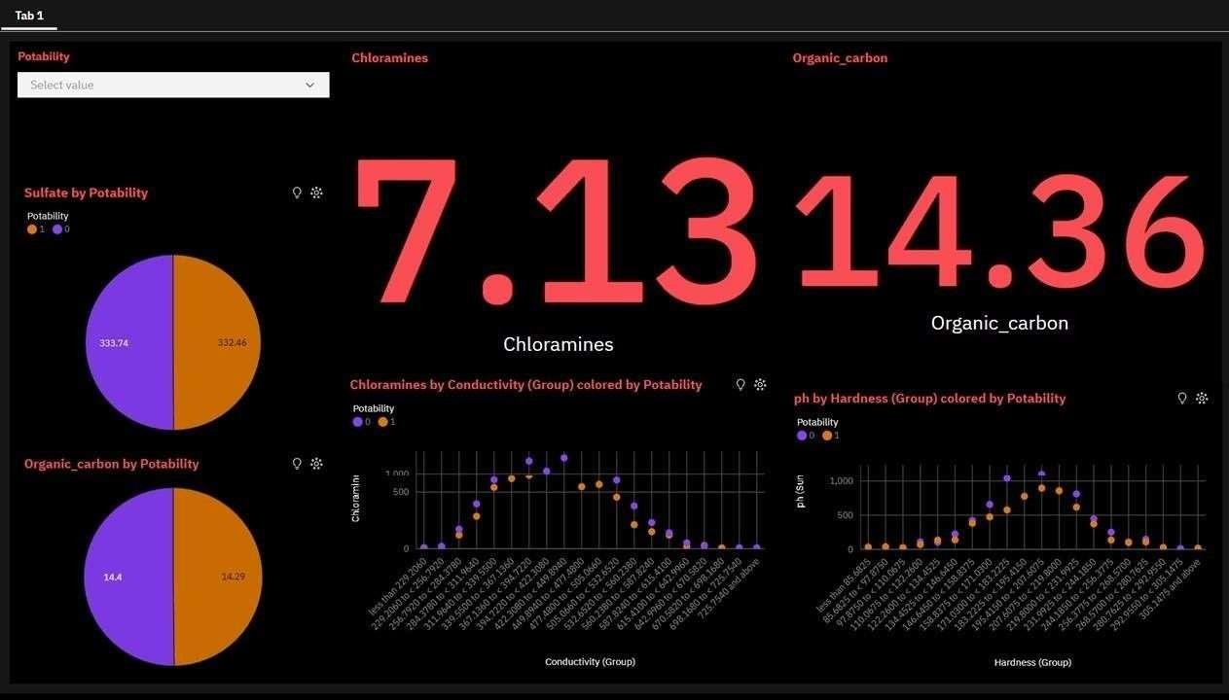

1. **ADVANTAGES & DISADVANTAGES**

## Advantages:

The project " Quantitative Analysis Of Candidates In 2019 Lok Sabha Elections " offers a range of advantages:

* + C Provides data-driven insights for evidence-based decision-making.
  + Enhances transparency and accountability in the electoral process.
  + Facilitates targeted policy and electoral reforms.
  + Supports informed strategies for political parties.
  + Helps identify underrepresented demographic groups.
  + Contributes to a better understanding of voter behavior.
  + Empowers researchers and analysts with valuable data.
  + Offers a comprehensive view of candidate and party dynamics.
  + Strengthens democratic processes through data analysis.
  + Promotes collaboration and knowledge-sharing among stakeholders.

These advantages collectively contribute to Quantitative Analysis Of Candidates In 2019 Lok Sabha Elections.

### Disadvantages:

The project " Quantitative Analysis Of Candidates In 2019 Lok Sabha Elections " comes with several potential disadvantages and challenges:

* + Requires substantial data collection and management efforts.
  + Data privacy and security concerns may arise.
  + Reliance on data quality, accuracy, and availability.
  + Implementation costs and resource requirements.
  + Potential challenges in data standardization and formatting.
  + Complex quantitative analysis may be challenging for some users.
  + The project's success relies on the availability of historical data.
  + Results are subject to interpretation and may not offer definitive solutions.
  + Limited impact without widespread adoption and use of findings.
  + May inadvertently reinforce the digital divide among stakeholders.

Mitigating these challenges will be vital for the project's success and its ability to deliver Quantitative Analysis Of Candidates In 2019 Lok Sabha Elections

# CONCLUSION

In conclusion, the "Quantitative Analysis of Candidates in the 2019 Lok Sabha Elections" project, powered by IBM Cognos, represents a crucial step towards fostering transparency and data-driven decision-making in India's democratic process. By meticulously dissecting candidate demographics, party performance, and voter behavior, the project empowers stakeholders with the invaluable tools needed for informed policy formulation and electoral strategies. While challenges like data management and privacy must be acknowledged, the project's advantages in promoting transparency, accountability, and equitable representation in Indian politics far outweigh these obstacles.

As the project concludes, it serves not as an endpoint but a catalyst for change. The insights gained from this endeavor are the building blocks for a fairer, more transparent political landscape and a testament to the potential of technology and data to fortify the essence of democracy. The journey continues, and the impact is boundless, promising a brighter future for India's electoral system.

### FUTURE SCOPE

The future scope for " Quantitative Analysis of Candidates in the 2019 Lok Sabha Elections " is expansive and promising. It includes:

* I Expansion to Other Election Cycles:
* Integration of Real-Time Data:
* Predictive Analysis and Forecasting:
* Comparative Studies and Benchmarking:
* Public Awareness and Education:
* Cross-Geographical Electoral Analysis:
* International Collaborations and Best Practices Sharing:

The future scope of the project encompasses a wide array of possibilities, including advanced data analysis techniques, real-time insights, and a more extensive impact on electoral research, governance, and public engagement. This project has the potential to drive innovation in the field of political analysis and contribute to the strengthening of democratic processes in India.

# APPENDIX

## Source Code:

### Index.html

<!DOCTYPE html>

<html lang="en">

<head>

<meta charset="UTF-8">

<meta name="viewport" content="width=device-width, initial-scale=1.0">

<title>Water Portable</title>

<style>

body {

background-color: rgb(0, 0, 0);

}

h1 {

text-align: center; font-size: 50px;

color: rgb(255, 255, 255);

}

h2 {

font-size: 25px;

color: rgb(255, 255, 255);

}

p {

font-size: 29px;

color: rgb(255, 255, 255);

}

.center-img {

text-align: center;

}

.center-img img { display: block; margin: 0 auto;

max-width: 100%; /* Ensure images don't exceed their container width */

}

</style>

</head>

<body>

<h1><b>Aquatic Insights</b></h1>

<h1><b>COGNOS POWERED</b></h1>

<h1><b>WATER PORTABILITY ANALYSIS</b></h1>

<h2>Here is the data analysis regarding water analysis. We have analyzed various data points such as pH values, hardness, TDS, chloramines, sulfate, conductivity, organic carbon, trihalomethanes, turbidity, and potability of the water samples.</h2>

<div class="center-img">

<img id="image1" src="C:/Users/murar/OneDrive/Desktop/NM/FINAL DELIVERABLES/templates/pic 1.png">

</div>

<h1>STORY BOARD</h1>

<p>Our analysis separates the samples as portable and non-portable, averages sulfate content for portable and non-portable water, summarizes chloramines taking their average, summarizes organic carbon content taking their average, and considers the average organic carbon content of portable and non-portable water. We also look at chloramines by conductivity (group) colored by potability and pH by hardness (group) colored by potability.</p>

<div class="center-img">

<img id="image2" src="C:/Users/murar/OneDrive/Desktop/NM/FINAL DELIVERABLES/templates/pic 2.png">

<img id="image3" src="C:/Users/murar/OneDrive/Desktop/NM/FINAL DELIVERABLES/templates/pic 3.png" style="display: none;">

</div>

<script>

// Image transition timer (5 seconds) setInterval(function() {

var image1 = document.getElementById("image1"); var image2 = document.getElementById("image2"); var image3 = document.getElementById("image3");

if (image2.style.display === "none") { image2.style.display = "block"; image3.style.display = "none";

} else {

image2.style.display = "none"; image3.style.display = "block";

}

}, 10000);

</script>

</body>

</html>

### App.py

from flask import Flask, render_template app = Flask( name )

@app.route("/") def index():

return render_template("index.html")if name ==" main ":

app.run()

## Github link:

**https://github.com/Varun-313/Naan-Mudhalvan**

## Project Demo Link:

**https://drive.google.com/file/d/1-wbZ6obNhTU0IXZ73cCdz50o-_tEl8B_/view?usp=sharing**